2019 OLEMA SAUVIGNON BLANC
LOIRE VALLEY

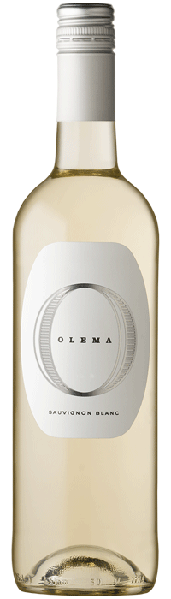

ABOUT THE WINE: A wine that encompasses freshness from start to finish, the 2019 Olema Sauvignon Blanc shows bright tropical aromas along with hints of honeysuckle and wet stone. On the palate, citrus flavors carry through a mouth-tingling acidity laced with lemon oil that carries through the long, zippy finish.

2019 VINTAGE: The 2019 vintage in France’s Loire Valley is “the latest in a string of great vintages” in the region, according to Decanter magazine. A dry, chilly spring was followed by a hot, dry summer, allowing the vines to develop slowly through the spring with ample ripening time in the following months. Wines from 2019 show distinct freshness and brightness, balanced by richness and concentration from the summer heat.

ALCOHOL: 12%

APPELLATION: Loire Valley, France

BLEND: 100% Sauvignon Blanc
SUGGESTED RETAIL PRICE: $15

